# Install Nagios Core on CentOS 7

**Step 1: Connect to your server**

ssh root@IP_ADDRESS -p PORT_NUMBER

and replace IP_ADDRESS and PORT_NUMBER with your actual server IP address and SSH port number.

[root@localhost ~]# yum update

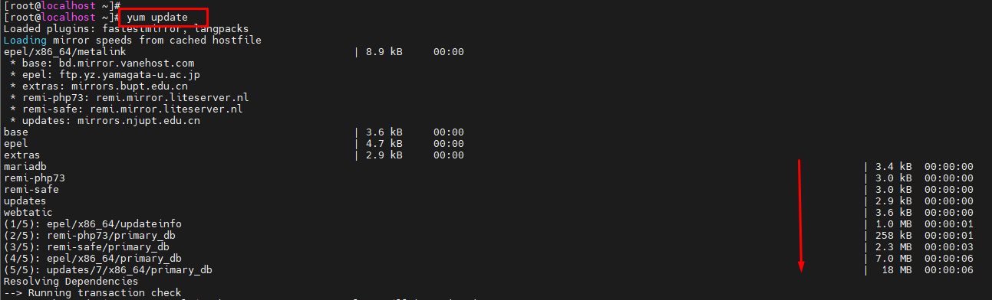

**Step 2: Install LAMP**

For Nagios Core to work on your server you will also need to set up a LAMP or any other web hosting stack. If you already have working web hosting stack installed on your server you can skip this and go to the next step of this tutorial.

To install a LAMP stack with Apache, MariaDB and PHP 7 on your CentOS server, run the following command:

[root@localhost ~]# yum install httpd mariadb-server php php-mysql -y

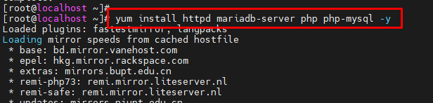

When the MariaDB installation is complete, you can also run the following command to secure your MariaDB installation:

[root@localhost ~]# mysql_secure_installation

You will also need to enable MariaDB and Apache to start on boot with:

[root@localhost ~]# systemctl enable httpd.service

[root@localhost ~]# systemctl enable mariadb.service

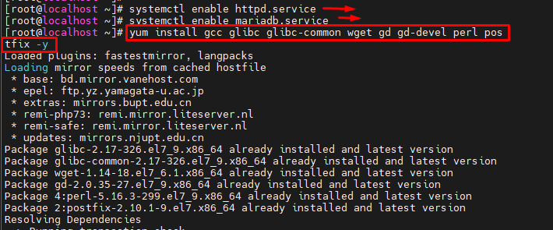**Step 3: Install the required packages**

The following packages are also be required by the Nagios Core software. You can install them with the following command:

[root@localhost ~]# yum install gcc glibc glibc-common wget gd gd-devel perl postfix -y



**Step 4: Download and Install Nagios Core**

Let’s download the latest stable version of the Nagios Core.

First, navigate to the tmp directory on your server with:

[root@localhost tmp]# cd /tmp

and run the following command to download the tar archive file:

[root@localhost tmp]# wget -O nagioscore.tar.gz <https://github.com/NagiosEnterprises/nagioscore/archive/nagios-4.4.2.tar.gz>

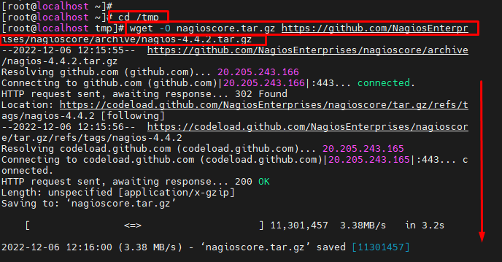

Once the download is complete, execute the following command to extract the archive file:

[root@localhost tmp]# tar xzf nagioscore.tar.gz



Once the archive is extracted, move to the nagioscore-nagios-4.4.2 directory:

[root@localhost tmp]# cd /tmp/nagioscore-nagios-4.4.2



and run the following command in order to configure the installer and prepare the Nagios Core source code for the compilation process:

[root@localhost nagioscore-nagios-4.4.2]# ./configure

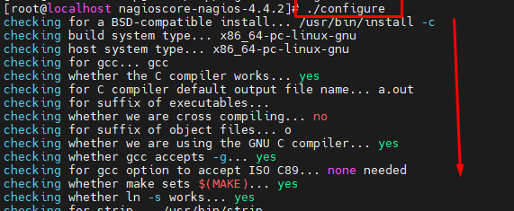

After the configuration is completed, you can now compile Nagios Core by execution the following command:

[root@localhost nagioscore-nagios-4.4.2]# make all

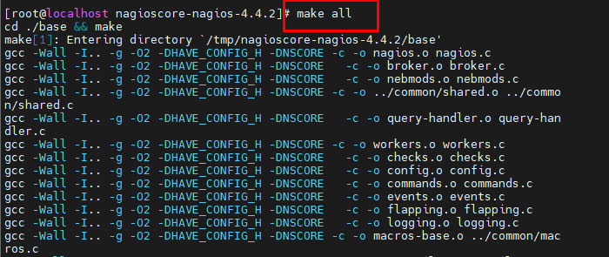

You also need to run the following commands to create the nagios user and group and add apache to the nagios group:

[root@localhost nagioscore-nagios-4.4.2]# make install-groups-users

[root@localhost nagioscore-nagios-4.4.2]# usermod -a -G nagios apache

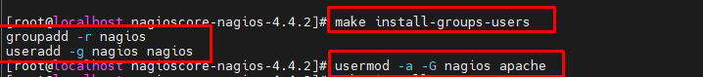

Now, you can finally run the following command in order to install Nagios Core:

[root@localhost nagioscore-nagios-4.4.2]# make install

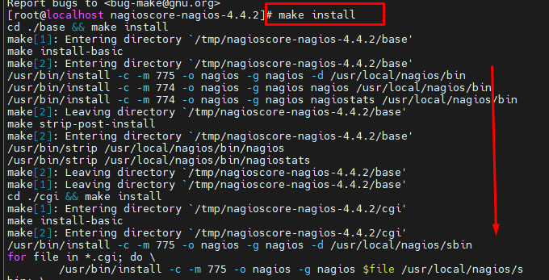

To, install the initialization script which can be used to manage your Nagios service, run the following command:

[root@localhost nagioscore-nagios-4.4.2]# make install-daemoninit

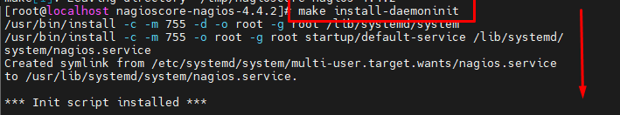

Next, run the following command to install the Nagios sample configuration files:

[root@localhost nagioscore-nagios-4.4.2]# make install-config

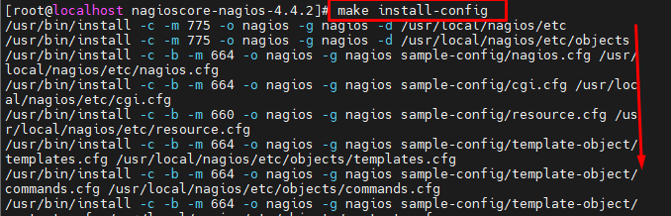

Run the following command to install and configure the external command file to make Nagios Core to work from the command line:

[root@localhost nagioscore-nagios-4.4.2]# make install-commandmode

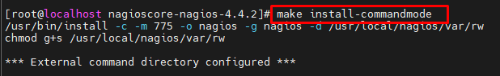

The following command will install the Apache web server configuration files:

[root@localhost nagioscore-nagios-4.4.2]# make install-webconf

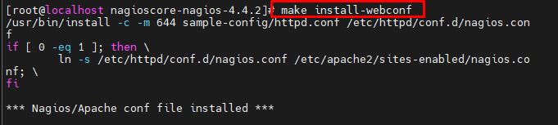

After all the installations are complete, restart your apache service with:

[root@localhost nagioscore-nagios-4.4.2]# systemctl restart httpd

**Step 5: Create nagiosadmin User Account**

To be able to log into Nagios, you will need to create an Apache user account.

You need to run the following command to create a new user account called nagiosadmin and assign a password to it:

[root@localhost nagioscore-nagios-4.4.2]# htpasswd -c /usr/local/nagios/etc/htpasswd.users nagiosadmin

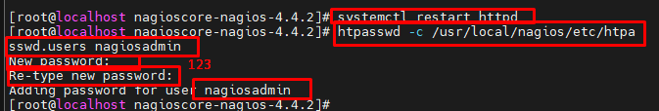

With this step, the main Nagios Core installation is now complete. However, for Nagios Core to operate properly you will also need to install the Nagios Plugins as explained in the next step.

**Step 6: Install Nagios Plugins**

Before you download and install the Nagios plugins, you need to make sure that the following packages are installed on your CentOS 7 server:

[root@localhost nagioscore-nagios-4.4.2]# yum install gcc glibc glibc-common make gettext automake autoconf wget openssl-devel net-snmp net-snmp-utils epel-release perl-Net-SNMP -y

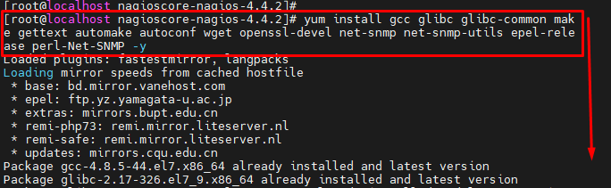

To download and extract the latest version of the Nagios Plugins to the tmp directory on your server, run the following commands:

[root@localhost nagioscore-nagios-4.4.2]# cd /tmp



[root@localhost tmp]# wget --no-check-certificate -O nagios-plugins.tar.gz <https://github.com/nagios-plugins/nagios-plugins/archive/release-2.2.1.tar.gz>

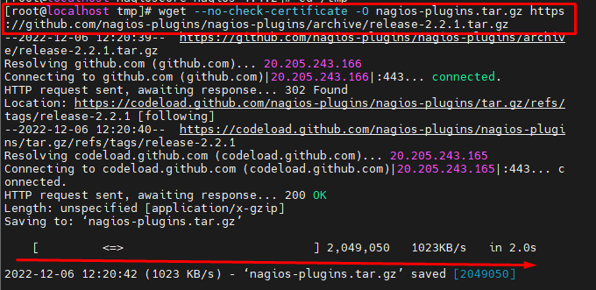

[root@localhost tmp]#tar zxf nagios-plugins.tar.gz

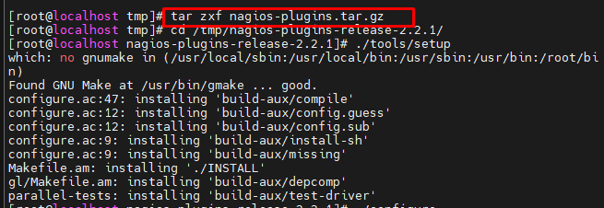

Once the Nagios Plugins archive is extracted, run the following commands to compile and install the Nagios Plugins on your server:

[root@localhost tmp]#cd /tmp/nagios-plugins-release-2.2.1/



[root@localhost nagios-plugins-release-2.2.1]#./tools/setup

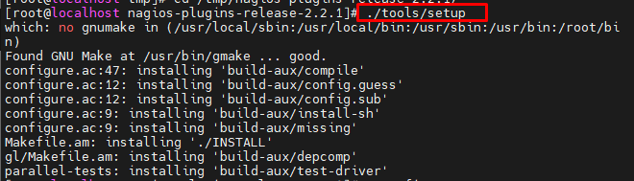

[root@localhost nagios-plugins-release-2.2.1]#./configure

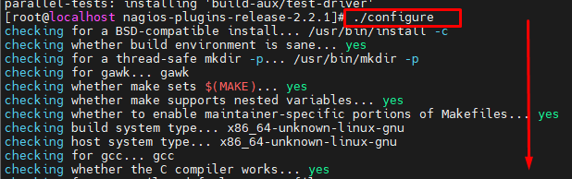

[root@localhost nagios-plugins-release-2.2.1]#Make

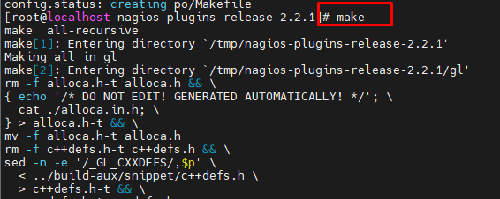

[root@localhost nagios-plugins-release-2.2.1]#make install

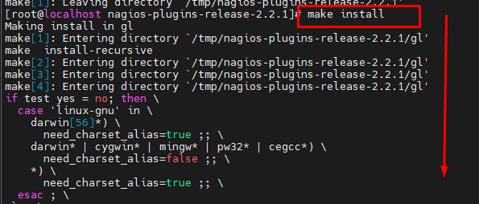

**Step 7: Accessing Nagios Core**

After you have successfully installed Nagios Core and the Nagios Plugins your CentOS 7 system, you can use the following command to start the Nagios service:

[root@localhost nagios-plugins-release-2.2.1]#systemctl start nagios

To access Nagios Core, open your browser and navigate to http://YOUR-IP-ADDRESS/nagios and log in using the **user:  nagiosadmin  password : 123** user account which you have created in one of the previous steps in this tutorial.

After you have successfully logged in, you will be presented with the Nagios Core home screen as shown in the image below:

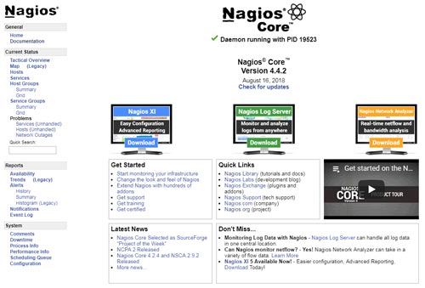

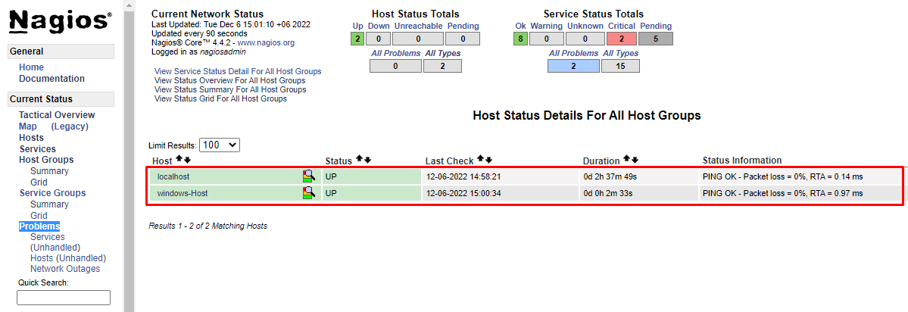

[root@localhost ~]# cd /usr/local/nagios/etc/

[root@localhost etc]# ls

[root@localhost etc]# vim nagios.cfg

# Definitions for monitoring a Windows machine

cfg_file=/usr/local/nagios/etc/objects/windows.cfg

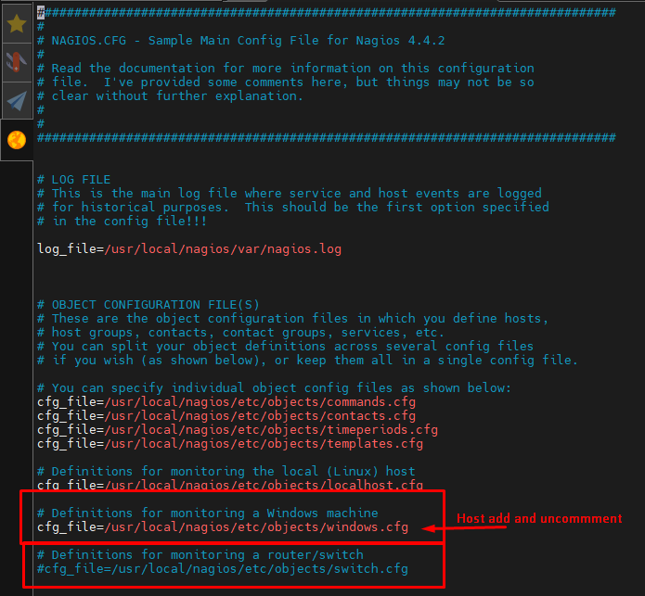

[root@localhost etc]# cd objects/

[root@localhost objects]# ls

[root@localhost objects]# vim windows.cfg

